^{Ghulam Murtaza}

^{Lab 05 B}
^{INSERT INTO STUDENTS}
(student_id,student_name,department,semester) VALUES (101,'Ali Khan','CS',3);
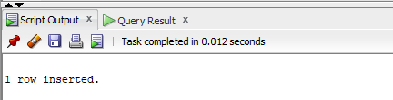

^{Question 2}
^{INSERT INTO STUDENTS}
(student_id,student_name,department,semester) VALUES (102,'Sara Ahmed','AI',2);
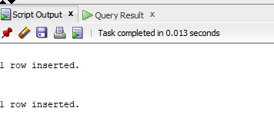

^{Question 3}
^{INSERT INTO Courses}
(course_id,course_name,credit_hours) VALUES (501,'Database Systems',3);
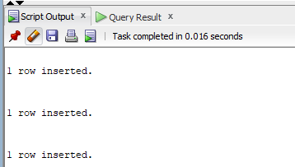

^{Question 4}
^{INSERT INTO Courses}
(course_id,course_name,credit_hours) VALUES (502,'Operating Systems',4);
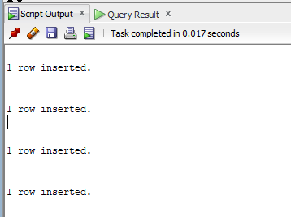

^{Question 5}
^{INSERT INTO Enrollments}
(enroll_id,student_id,course_id,grade) VALUES (1,101,501,'A');


^{Question 6}
^{UPDATE STUDENTS SET}
semester=3 WHERE student_id=102;
^{COMMIT;}

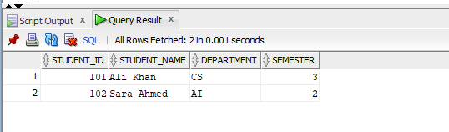

^{Question 7}
^{UPDATE COURSES SET}
credit_hours=4 where course_id=501;
^{COMMIT;}
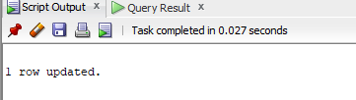
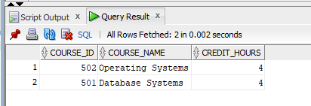

^{Question 8}
^{UPDATE ENROLLMENTS SET}
grade='A+' where course_id=501 AND student_id=101;
^{COMMIT;}

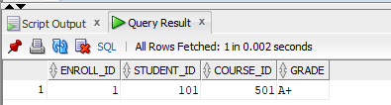

^{Question 9}
^{DELETE FROM STUDENTS}
^{WHERE student_id=102;}
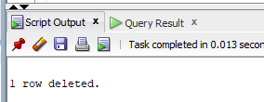
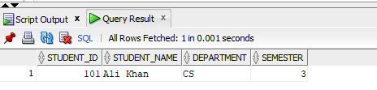

^{Question 10}
DELETE FROM COURSES WHERE course_id=502;
